5.1 Parametric Equations

Not all curves pass the vertical line test. It is impossible to describe such curves in the form. The idea in this section is to express such curves in the xy-plane with parametric equations.

Terminology: Suppose x and y are both given as functions of a third variable t (called a parameter). In terms of equations we write:

and we call theses equations parametric equations. Each value of t determines a point which we can plot in the plane. As t varies we can trace out a curve determined by the parametric equations which we will call the parametric curve.

Example 1: (a) Sketch the curve given by the parametric equations: .

We begin by creating a table to identify some points to graph:

t | x | y
-2 | 8 | -3
-1 | 3 | -2
0 | 0 | -1
1 | -1 | 0
2 | 0 | 1
3 | 3 | 2

Now, the graph is:

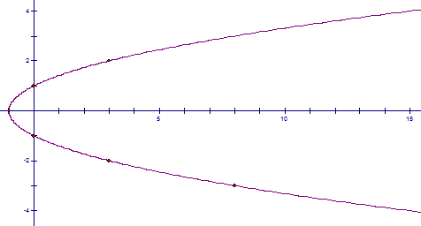

(b) Describe this curve with a single equation which does not have the parameter t in it.

We note that . So, if we perform a substitution we find that an equation which describes the curve is: .

Example 2: One nice application of parametric equations is that they can be used to model the movement of a particle that traverses some curve in the plane (in some applications we view t as the time variable). Draw the path traversed by a particle whose movement is modeled by the parametric equations:

where .

For this question the path is part of the graph of the previous example with an orientation:

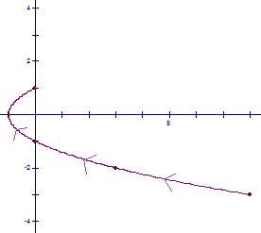

Note: In the above example the point (where the particle starts) is called the initial point, and the point (where the particle ends) is called the terminal point.

Note: Many graphs that cannot be graphed in xy-coordinates can be expressed as parametric equations.

Example 3: Graph parametrically.

We first need to convert this equation to a parametrically defined equation.
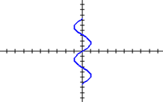
If we let then we obtain:

Example 4 (you try): (unrelated parts)
- Sketch the curve with parametric equations:
We note that these equations imply , but since the range values of cosine are in , we only get part of this parabola. The answer is:

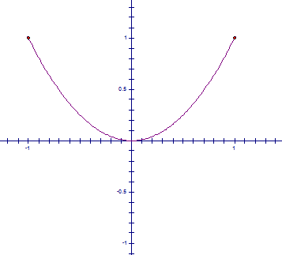

- Find parametric equations for the curve determined by the equation:

If we let , we obtain the parametric equations: .

- Find parametric equations which describe the movement of a particle which traverses a circle of radius 4 exactly one time in the counterclockwise direction.

One possibility is: where .

Calculus with Parametric Curves

Motivation: Suppose and are differentiable functions and we want to find the tangent line at a point on the curve , . If we suppose that y is a differentiable function of x. Then, we know by the chain rule:

.

Now, we can solve for provided that .

Note: The subtlety here is that in general y may not be a function of x. We said early that one of the main reasons we use parametric equations is due to the fact that y is not a function of x. In more advanced mathematics (namely real analysis) one can prove that, when , then “y is locally a function of x” (the definition of locally is beyond the scope of the course). This is great news because it leads to the following theorem which gives us a rule for differentiation.

Theorem: If and are differentiable functions with , and , then

Note: The proof of this theorem is beyond the scope of the course.

Note: The parametric curve given by , has a horizontal tangent when provided . The parametric curve given by , has a vertical tangent when provided . When both and are 0 a careful analysis is needed (see 7.4.1).
Note: rather

Example 5: Suppose that a curve C is defined by the parametric equations , .

- Find the equation of both tangent lines to C at .

To find the value(s) of t which correspond to the point we solve . We notice that the t values of both 3 and -3 correspond to the point on C.
By the above theorem we know that for , . This means there is a tangent line at with slope and a tangent line at with slope .
Now, we use point slope form of a line to write the equations of both tangent lines at . In particular the answer is: and .

- Find the point(s) on C where a tangent is horizontal or vertical.

A tangent will be horizontal for the point(s) corresponding to values of t which satisfy: and . Now, we plug these values of t into the parametric equations and we find that there is a horizontal tangent at the points and .
A tangent will be vertical for the point(s) corresponding to values of t which satisfy: and . Now, we plug this value of t into the parametric equations and we find that there is a vertical tangent at the point .

- For what values of t is the curve concave upward/downward.

First we calculate: provided . Now, we notice that is positive for and is negative for . This means that C is concave upward for , and C is concave downward for .

Note: One can check the reasonableness of the answers by graphing the curve on the calculator.

Example 6 (you try):
For which values of t is the curve given by , concave upward/downward.

By the theorem we know that for we have . Then, for we have: . Now, we want to know all the values of t such that . We note that the numerator of the expression on the left is positive for and negative for . Also the denominator of the expression on the left is positive for and negative for .

The curve is concave downward for .

The curve is concave upward for or .

Using the ideas from chapter 2 & 3 we can find ways to compute areas beneath/between parametric curves and derive formulas for arc length and surface area in the setting of parametric equations. We will only discuss arc length. I will include extra (optional) notes on the other topics mentioned above and other details are in the textbook.

Theorem: If a curve C is described by the parametric equations , , where and are continuous on and C is traversed exactly once as t increases from to , then the arc length of C is
.

Proof: Shown in the textbook.

Example 7: Find the exact length of the curve given by where .

We note that and . We note that both of these derivatives are continuous on , and since the function for y is a decreasing function we know that the curve is only traversed once as t increases from 0 to 3. Thus, the above theorem applies and the length is:

Example 8 (you try): Set up an integral that represents the length of the curve given by where . Then, use your calculator to find the approximate length to four decimal places.

Solution: We note that and . We note that both of these derivatives are continuous on , and since the function for y is increasing on , we know that the curve is only traversed once as t increases from 1 to 4. Thus, the above theorem applies and the length is: .

OPTIONAL MATERIAL: NOT COVERED ON HOMEWORK OR EXAMS.

Now we will explore integration and areas under curves given by parametric equations.

Definition: Suppose we have a circle of radius r with center . Fix point P as the point on the circle which coincides with the origin. The curve that P traverses as the circle rolls along the x-axis is known as a cycloid.

Fact: The parametric equations of the cycloid are:

Note: Details on cycloids can be found on in the textbook.

Example 1: Use your calculator to graph the cycloid given by: .

The key thing to remember here is that you may have to go to window and adjust the T minimum and T maximum in order to get a full picture. Also if your T step is too far apart your picture may not be accurate.

Example 2: Find the area under one arch of the cycloid given by .

From the graph of a cycloid, we know that one arch of the cycloid is traced as varies from 0 to . We also know that this arch of the cycloid starts at the origin and ends at the point in the xy-plane.

From Calculus 1 we know that the desired area is given by the definite integral: . This integral is tough to evaluate since y is not written in terms of x. So, we rewrite the integral in terms of .

To do this, we note that , and by what we have already mentioned, the new limits of integration will be and (since one arch of the cycloid is traced as varies from 0 to ). Now, we have:
Example 3 (you try): Find the area enclosed by the curve given by and the y-axis.

We see that portion of the curve that we are interested in is traced as t varies from 0 to 2. We see that the portion of the curve traced as t varies from 0 to 2 starts at the origin and ends at . The (signed) area that we are interested in is given by the integral: . We note that (assuming that ). Thus, the integral becomes
Assuming that we want a positive area (and not a signed area) the answer is: .
Theorem: If a curve C is described by the parametric equations where is rotated about the x-axis, where and are continuous on and , then area of the resulting surface is
.

Note: In this theorem we have

Example 4: Find the exact surface area of the surface obtained by rotating the curve given by where about the x-axis.

From a previous example we know that and are continuous on . We also know that the function describing y is nonnegative on . Thus, the above theorem applies and the surface area is:

